https://www.jdoodle.com/embed/v0/68cF
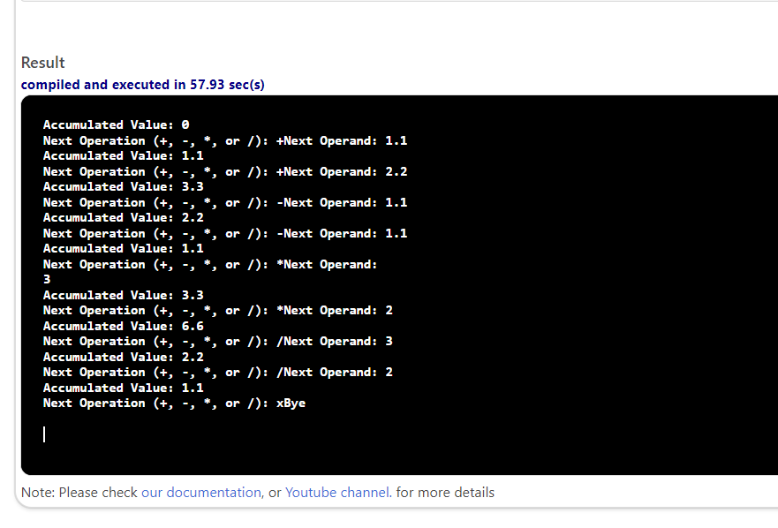

#include <iostream>
using namespace std;

double accumulate2(double acc, double opd, char op);

double accumulate2(double acc, double opd, char op)
{
double res;
switch (op)
{
case '+':
res = acc + opd;
break;

case '-':
res = acc - opd;
break;

case '*':
res = acc * opd;
break;

case '/':
if (opd != 0)
res = acc / opd;
else
cout << "Error: division by zero" << endl;
break;
default:
cout << "Invalid operation" << endl;
res = acc;

}
return res;
}

int main()
{
double accumulator = 0;
char operation;
double operand;
cout << "Accumulated Value: " << accumulator << endl;

cout << "Next Operation (+, -, *, or /): ";
cin >> operation;
while (operation == '+' || operation == '-' || operation == '*' || operation == '/')

{
cout << "Next Operand: ";
cin >> operand;
accumulator = accumulate2(accumulator, operand, operation);

cout << "Accumulated Value: " << accumulator << endl;

cout << "Next Operation (+, -, *, or /): ";
cin >> operation;
}
cout << "Bye" << endl;
return 0;
}

